Room Booking system

Abstraction:
An application to manage UB south hall booking system, in which any student of UB would able to register and login into the system to book room in south hall. An individual would be able to update and maintain his profile once the booking is done, user would be able to book, cancel and modify his data.

Project Name:
Room booking system
Project Requirements:
- Server – Apache
- Language - PHP
- Database server - MySQL
- web pages - HTML
- Connectivity - Ajax
Problem Statement:
It will be an application to manage south hall room booking system. An application where a student or an employee should be able to register and login to check the room available in the south hall and to book the room. All the information with respect to the users will be present in the system and according to their roles user should be able to check, book and cancel the rooms. System will have two users, first an administrator/manager who will have complete permission into the system and will be able to do any changes or generate records from the system. Second will be the normal user who can register and login to check the rooms available, book or cancel them over a period and to do any modification to their reservations. Normal User will be able to request the administrator for any changes or complaint regarding any issues to the admin. Room booking will be classified into the category based on the genders(Male/Female), number of persons in a room (single/double occupation), floor selection (1st/2nd/3rd /4th floor). Administrator user will be able to check on the feedbacks given by the normal user. Also, admin will be able to validate the login of the normal user when the user opts for forget password or change the password through a pre-defined security question.

Realistic Queries:
- Number of reservations in any given day
- Get details of reservations of a Room Number of reservation per semester.
- Number of reservations in any given month
- Youngest student details in first semester.
- Room with maximum queries
- What is the most used security question
- Rooms which are not fully occupied
- Get the location from which most students are registered
- Updating user profiles.
- Preference of occupants on room sharing, single, 2 sharing or 3 sharing.
- Recovering the forgot password
- Total reservation of rooms annually.
- Update security question and answer.
- Total number of international and US origin students.
- Room with maximum queries.

Assumption About the Database:
Entities:
USERS, ROOMRESERVATIONS, DEPARTMENT, LOCATION, ROOMS, QUERIES, RATING, SECURITY QUESTION
Attributes:
USERS: UBId, username, password, name, age, date of birth, gender, contact, departmentID, semester, origin/country (international/US), securityQuestion, SecurityQuestionAnswer.
ROOMRESERVATIONS: reservation ID, date and time, reserved by (UBId), room Id, semesters, end time
SECURITYQUESTION: ID, Question.
ROOM: Room ID, number of occupancy, floor ID.
QUERIES: QueryID, RoomID, UBId, CreatedOn, Query, Response, RespondedOn
DEPARTMENT: ID, Name
LOCATION: ID, Name
RATING: RatingID, UBID, Semester, RatedOn, Rating, RoomID
Relationship between entities
- User registers as a normal or admin ROLE
- User reserves the ROOM.
- User ID acts a key between USERS and ROOMRESERVATION.
- RESERVATION will block or communicate with ROOM.
- Room ID will be a key between RESERVATION and QUERIES

Phase II:

Enhanced Entity Relationship diagram:

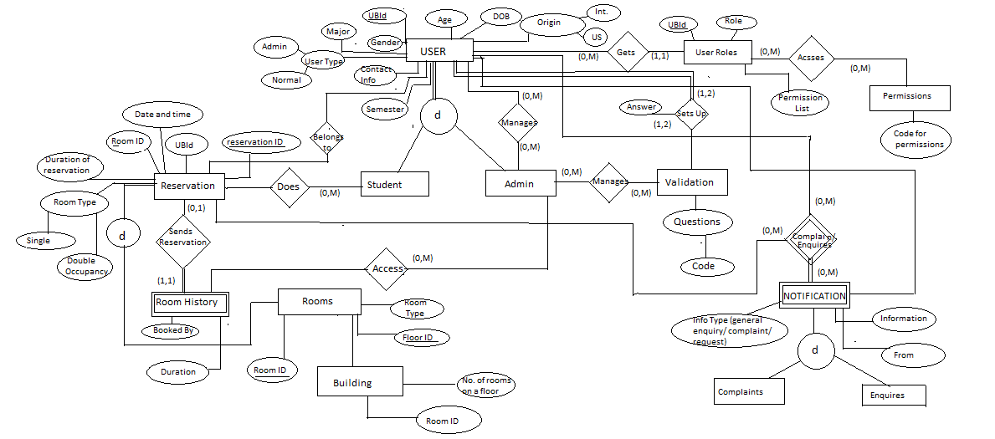

Relational Schema Diagram:

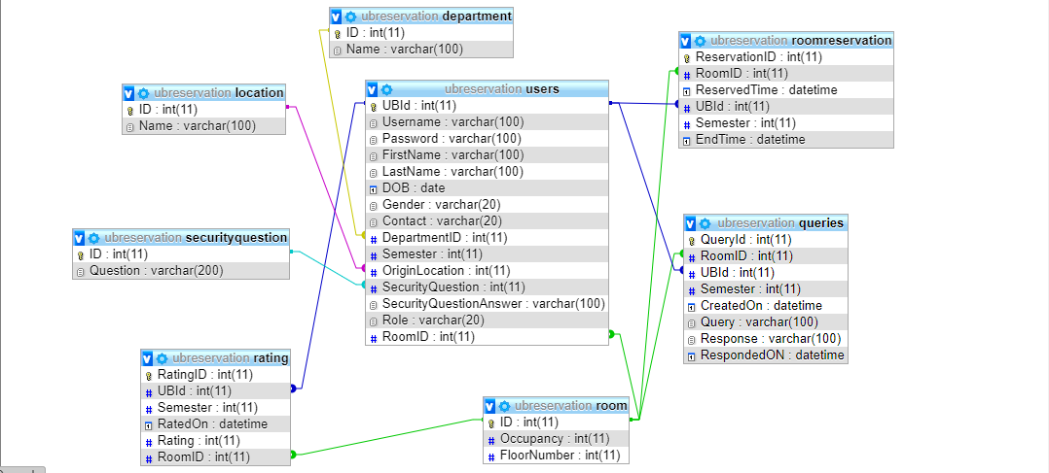

Phase III:
Relation Algebra for the quaries metioned above:
- R_ID ← σ_{RoomID} ((RESERVATION) ⋈_{RoomID=RoomID} (ROOM))
R2_ID ← σ_{RoomID} (ROOM)
RESULT ← π_{RoomID!=RoomID}(R_ID UNION R2_ID)
- π_{Count} (σ_{ReservationID} ( σ_{Data=yyyy} (RESERVATION))
- For summer semester:
π_{Semsester} (σ_{sesmester = summer}(RESERVATION))
For Fall Semester:
π_{Semsester} (σ_{sesmester = summer}(RESERVATION))
For Spring semester:
π_{Semsester} (σ_{sesmester = summer}(RESERVATION))
- πuserID,RoomID,RoomType,bookedby,semester (σuserID,RoomID,RoomType,bookedby,semester (ROOM_HISTORY))
- π_{FloorID} (σ_{FloorID} ((ROOM) ⋈_{RoomID=RoomID} (RESERVATION)))
- π_{UserID,Information} (σ_{type=complaint}(NOTIFICATION))
- π_{ReservedTill} (σ_{ReserveredID,Sesmester}(RESERVATION))
- π_{userID} (σ_{age>=15 AND age<=25}(USERS))
- π_{NumberOfOccupent} (σ_{NumberOfOccupent} ((RESERVATION) ⋈_{RoomType=RoomType} (ROOM)))
- π_{userID} (σ_{userID} ((USER_ROLES) ⋈_{Role=Role} (PERMISSIONS)))
- π_{reservationID} ( σ_{Data=yyyy} (RESERVATION))
- ρ_{Answer} (σ_{QuestionID} ((VALIDATION) ⋈_{userID=userID} (USERS))
- π_{UserID} ( σ_{origin!=US} (USERS))

System Set up using GCP:
- Start with installation of Python, pip, mysql and mysqlclient.
- Create an instance in GCP and contect mysql for the host server.
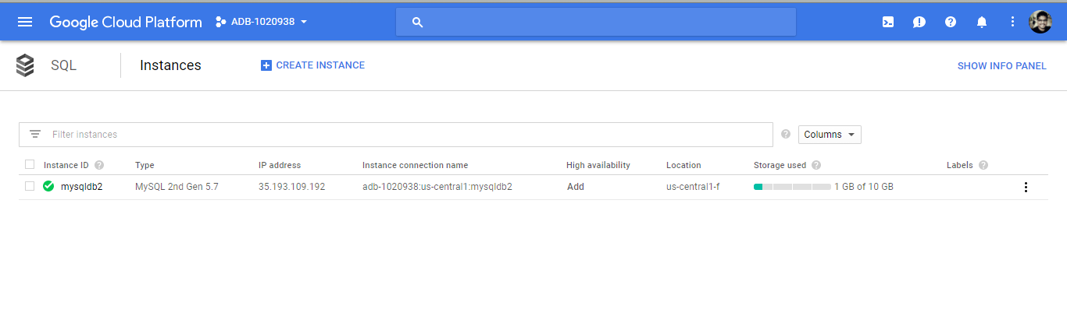
- Complete installation of django in using
$ pip install django –1.11.4
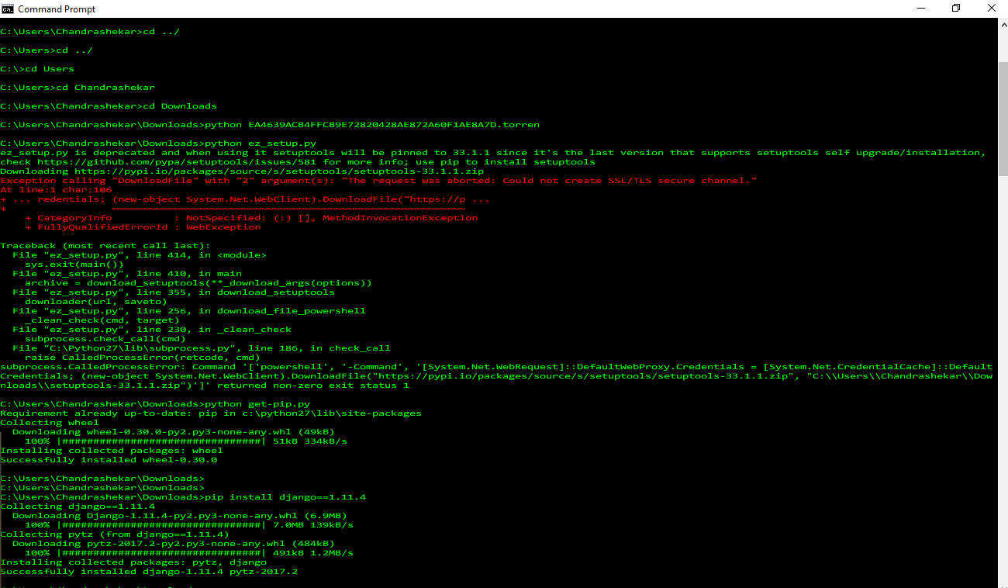
- Create a Django project using command line command,
$ django-admin startproject ADB_Dhanush
- Create a Django app using command line command,
$ python manage.py startapp projectapp
- Do the necessary amendments in the project files, setting.py, url.py, views.py and models.py.
In the ADB_Dhanush folder, create another folder as templates for storing the home.html file.
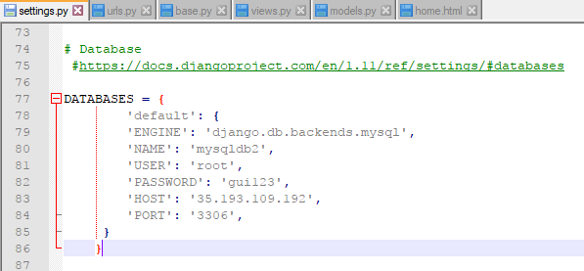
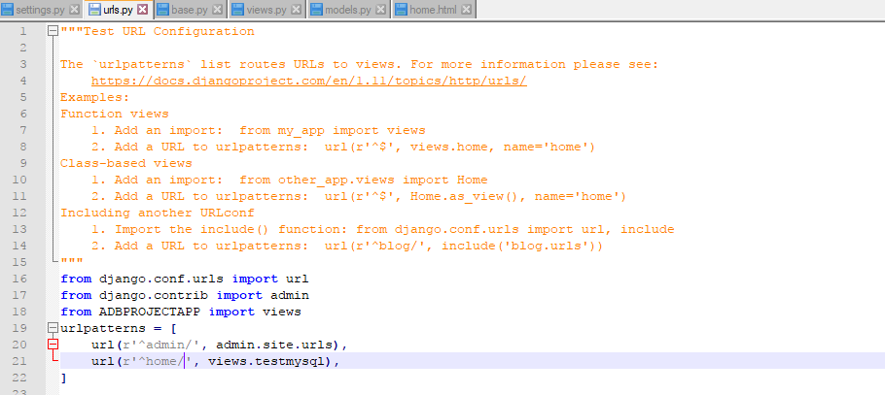
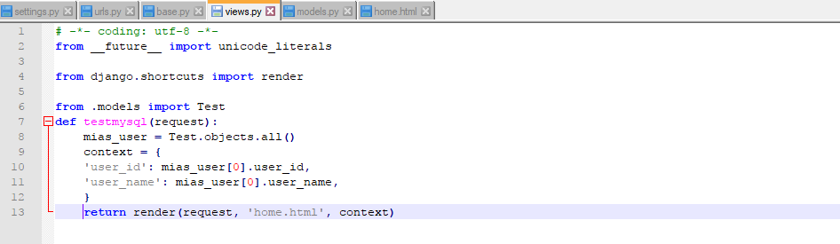
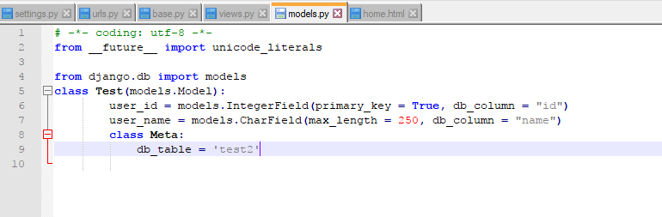
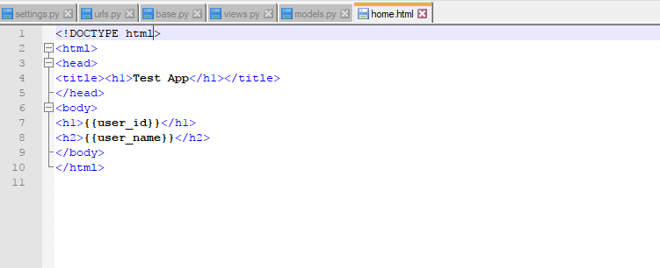
- Run the server using the following command:
$ python manage.py runserver
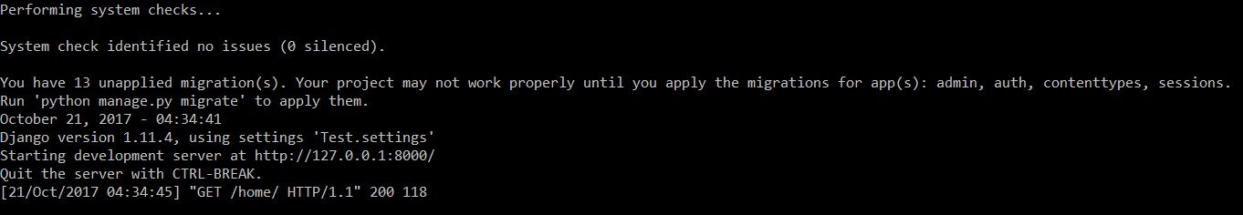
Using the url: http://127.0.0.1:8000/home, we can check the connection on a browser. This confirms the web server connection.
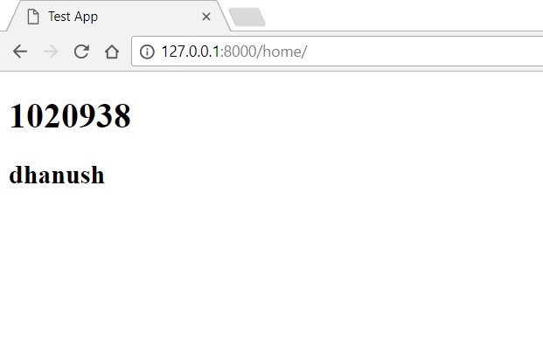
- Once this done, the same steps needs to be followed while developing a connecting in GCP. In GCP, we can use the cloud shell.
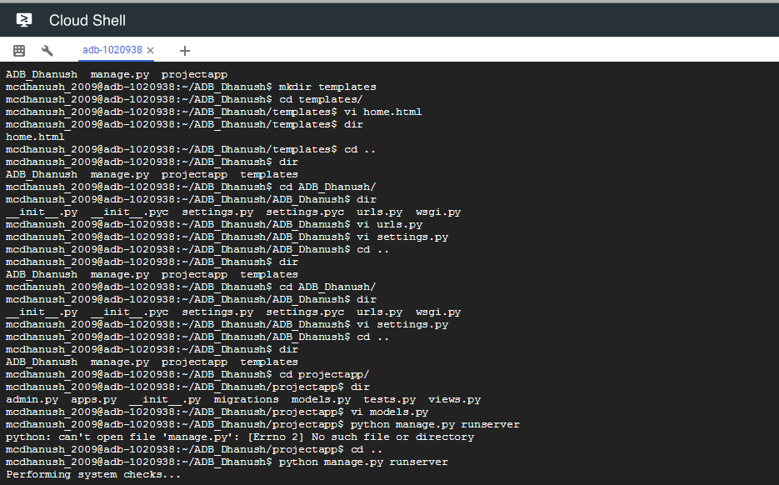
Observation: Cloude shell is throwing an error, django.db.utils.OperationalError: (2003, "Can't connect to MySQL server on '35.192.109.192' (110)")
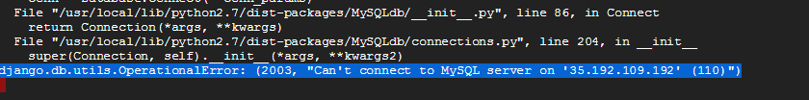

Phase IV:
Table Creation:
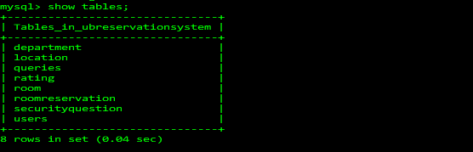
Inserting data into Department table:
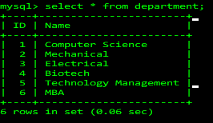
Inserting data into Location table:
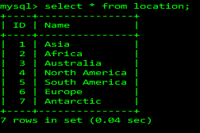

Inserting data into securityquestion table:
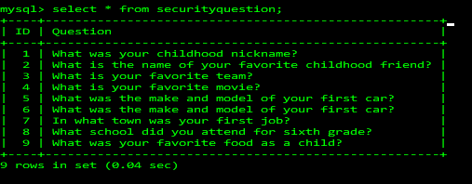
Inserting data into room table:
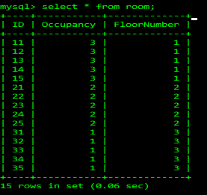
Inserting data into user table:
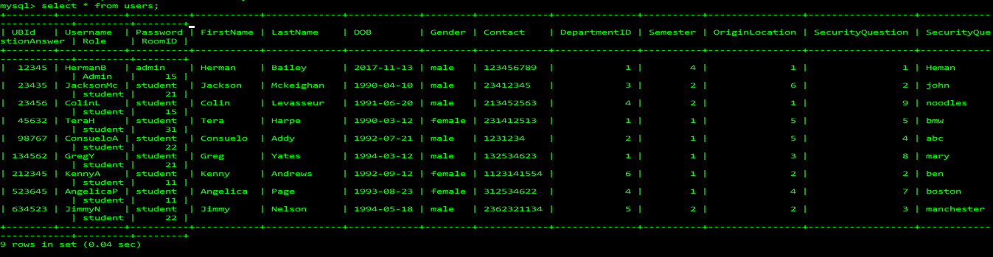
Inserting data into roomreservation table:
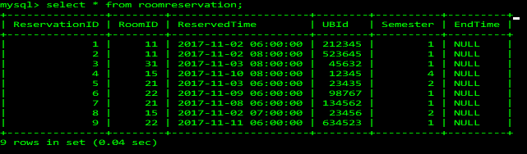

Testing SQL script files using MySQL Workbench:
dbDDL.sql Script:
Screen Shot:
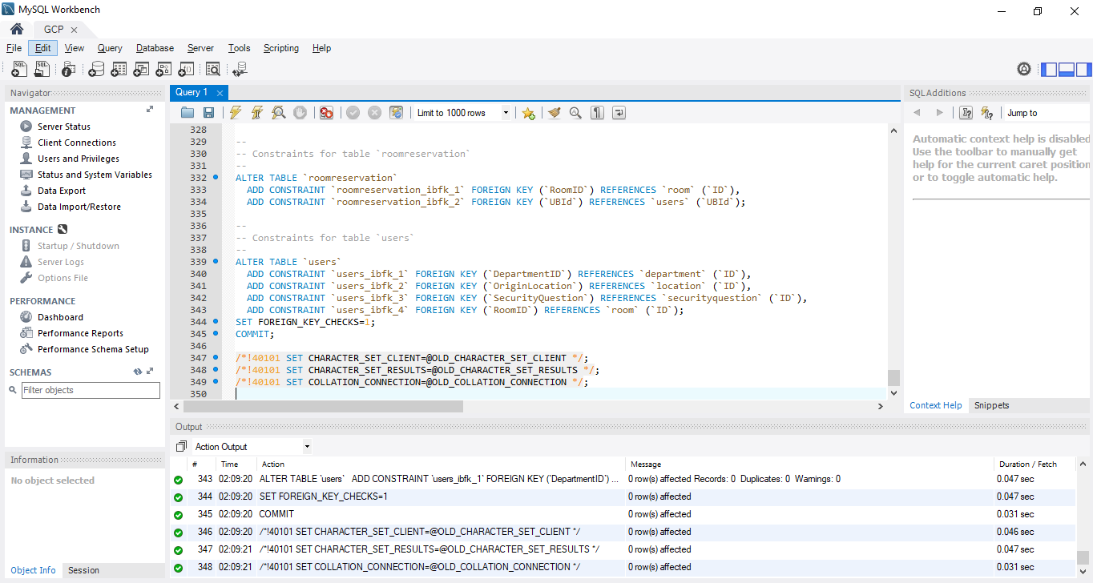

dbDML.sql Script:
Screen Shot:
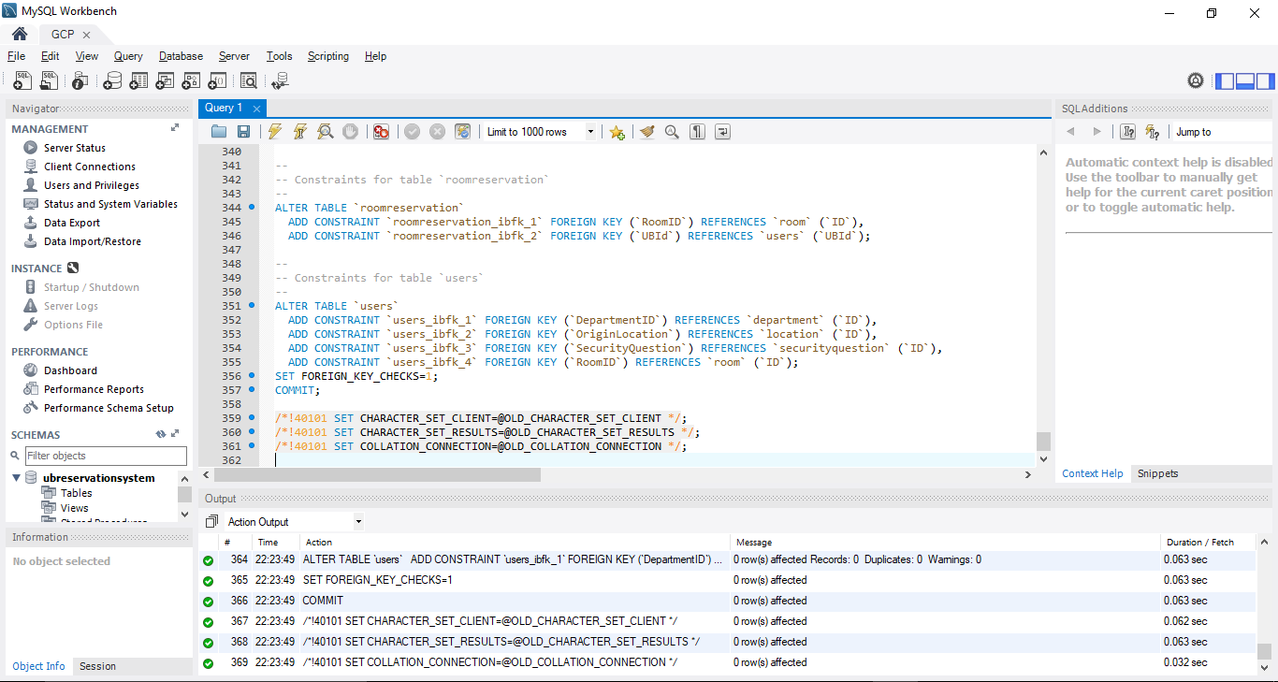

dbDROP.sql Script:
Screenshot:
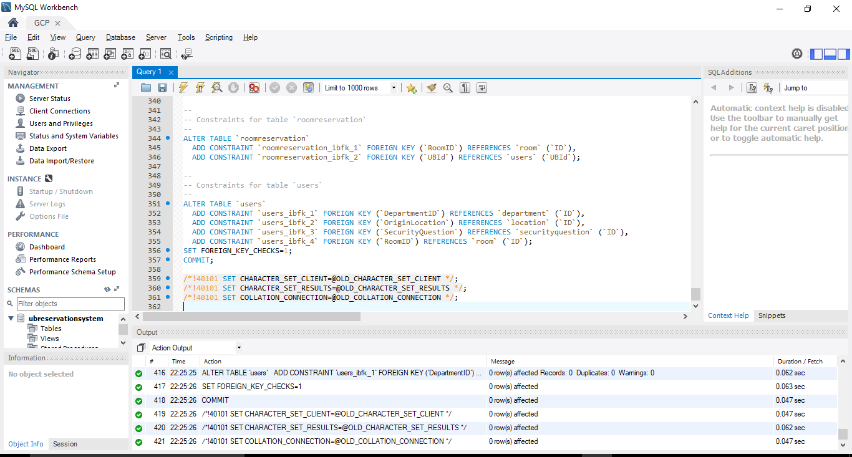

Queries Execution:
1 -- number of reservations in any given day

SELECT COUNT(*) as numberofreservations FROM `roomreservation` WHERE DATE(`ReservedTime`) = '2017-11-02';

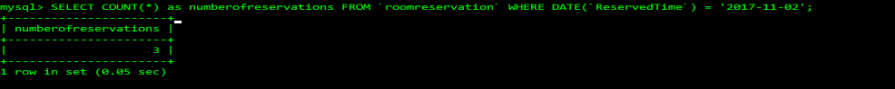

2 -- number of reservations in any given month

SELECT COUNT(*) as numberofreservations FROM `roomreservation` WHERE MONTHNAME(`ReservedTime`) = 'November';
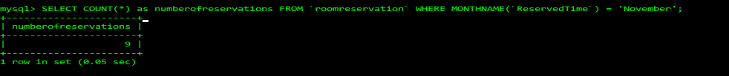

3 -- get details of reservations of a particular room

SELECT roomreservation.*, users.* FROM `roomreservation` inner join users on users.UBId=roomreservation.UBId WHERE roomreservation.RoomID=21;
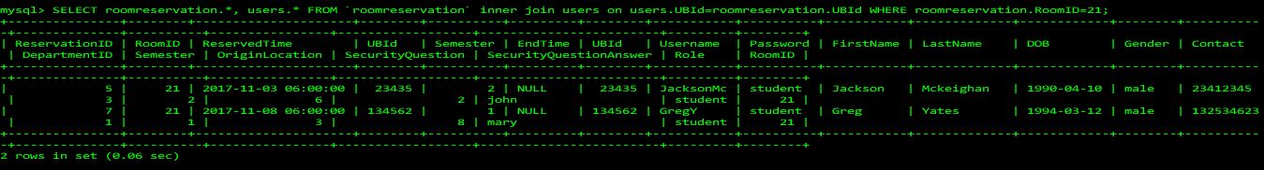

4 -- youngest student details

SELECT * FROM `users` WHERE `DOB`=(SELECT MAX(`DOB`) FROM users);
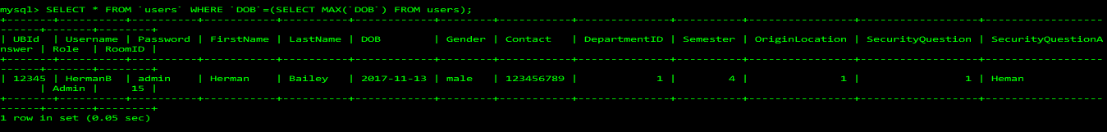

5 -- room with maximum queries

SELECT room.* FROM room INNER JOIN queries on queries.RoomID=room.ID GROUP BY room.ID ORDER BY COUNT(*) DESC LIMIT 1;
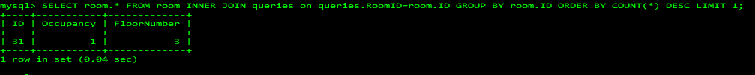

6 -- what is the most used security question

SELECT securityquestion.Question FROM `users` INNER JOIN securityquestion on securityquestion.ID=users.SecurityQuestion GROUP BY securityquestion.ID ORDER BY COUNT(*) DESC LIMIT 1;

7 -- rooms which are not fully occupied

SELECT room.* FROM `room` INNER JOIN roomreservation ON roomreservation.RoomID=room.ID WHERE roomreservation.EndTime IS NULL GROUP BY room.ID HAVING COUNT(*) <> room.Occupancy;

8 -- get the location from which most students are registered

SELECT location.Name FROM `users` INNER JOIN location ON location.ID=users.OriginLocation GROUP BY users.OriginLocation ORDER BY COUNT(*) DESC LIMIT 1;

Phase V:
Login Pages Screenshots:
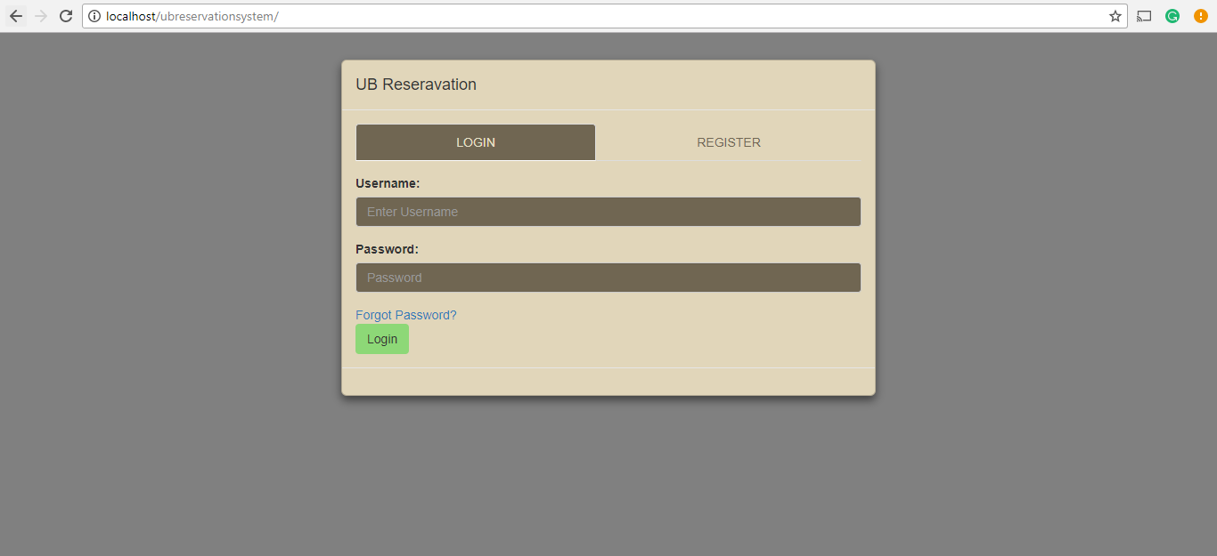
Student User Registration Page:
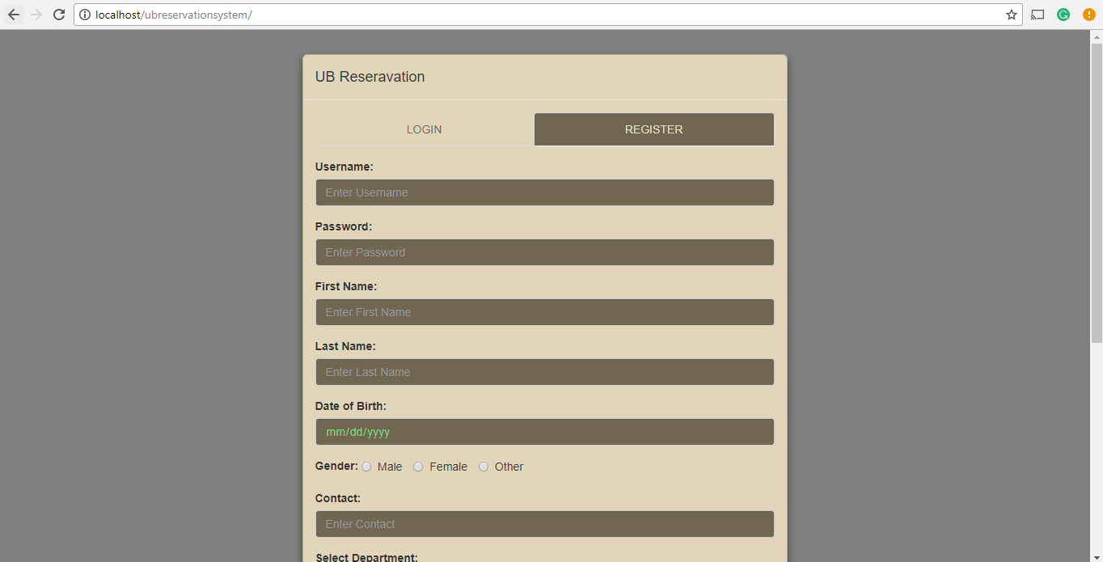
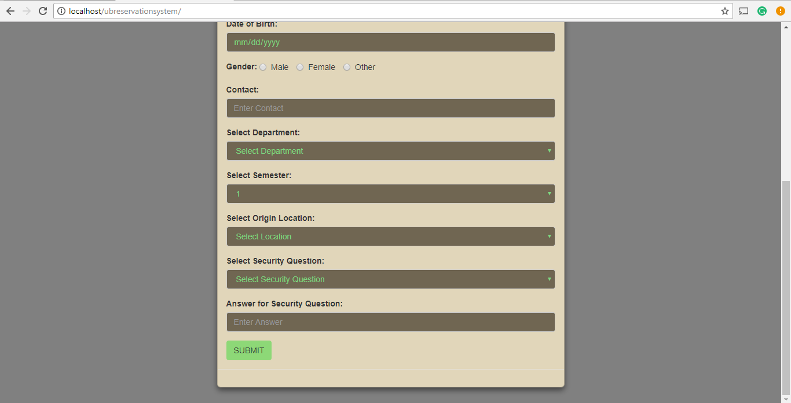

Registering New Student User:
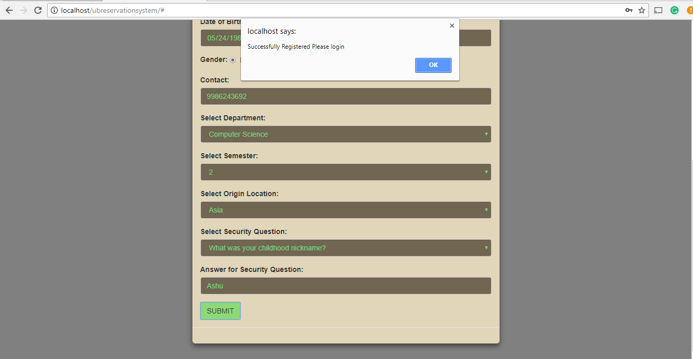
Login new user:
1.
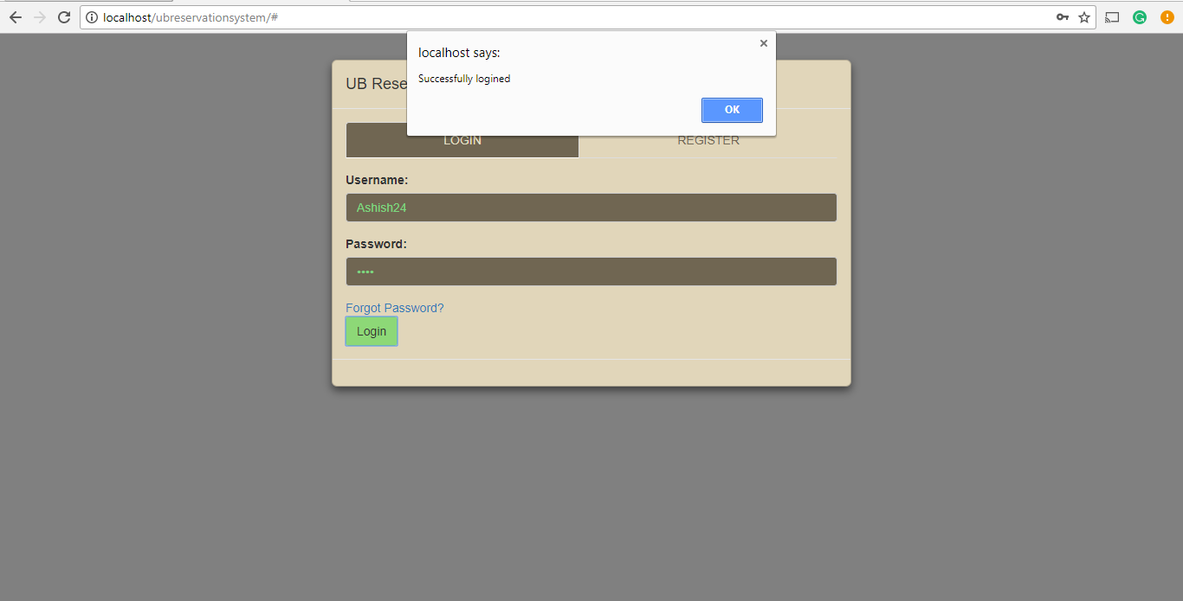

2.
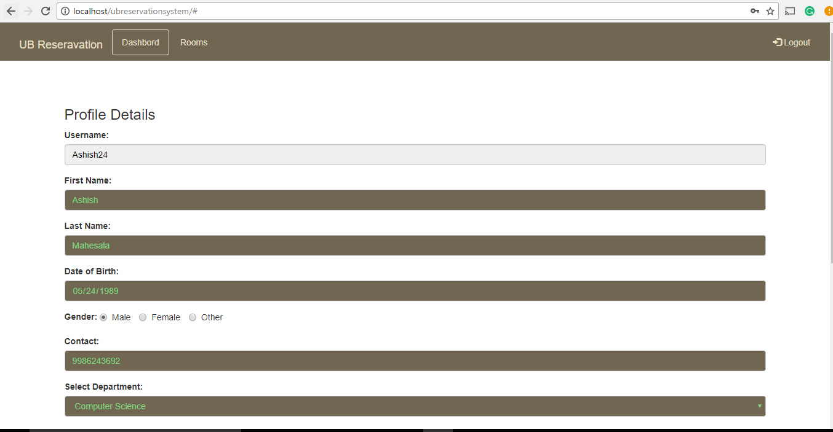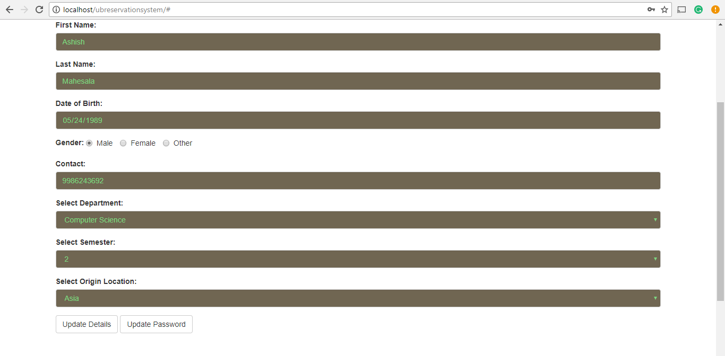
Update Details: To edit any profile details and save the changes. Any changes done here will update the database.
Update Password: To edit the login password and save the new password
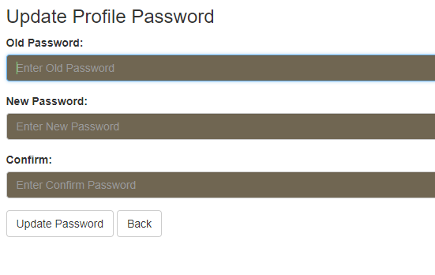
Room Reservation by the log-in user:
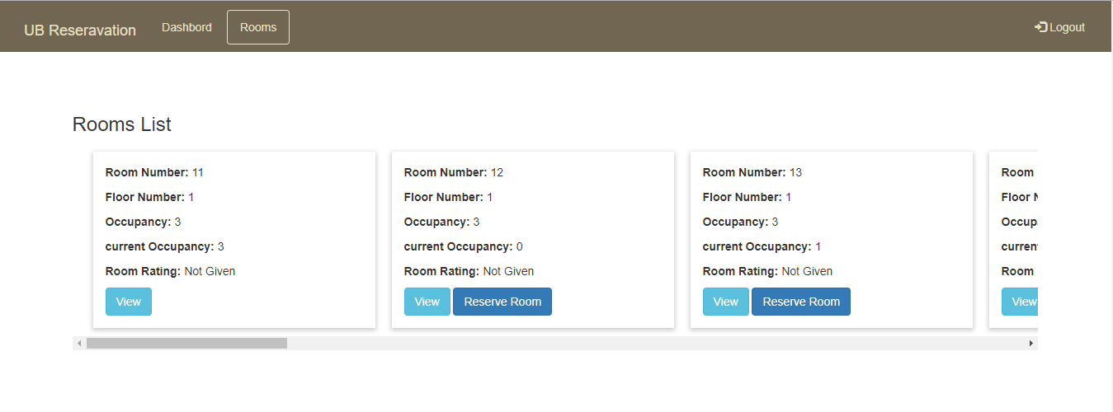
This is the menu which shows all the room available in the hostel. This page allows the login user to reserve room based on the number of occupancies.
For Example: In the above screenshot Room number: 11 has only view button because the room capacity (occupancy) and current occupancy is same, which means the room is full and cannot reserve it. Whereas for Room Number: 12 has both view and reserve room because the room has not yet been reserved by anyone.

Updated database with new user:
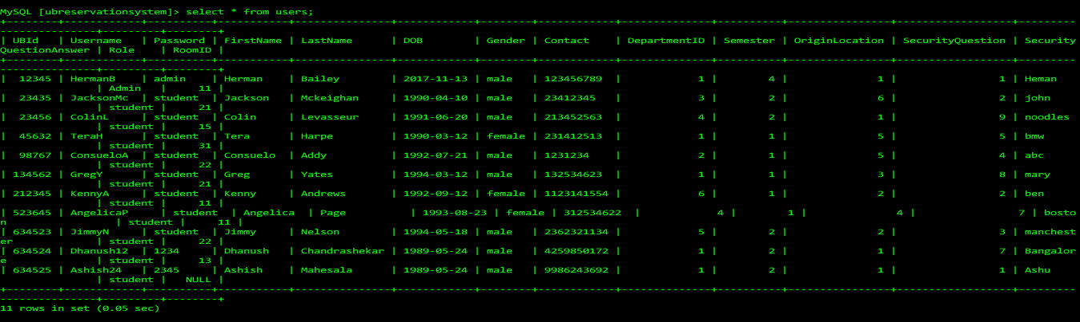
Reserved room for login user:
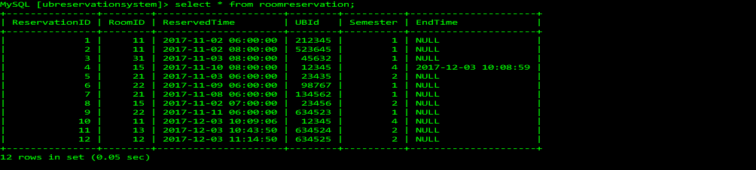
Admin Login Page:
Handling queries:
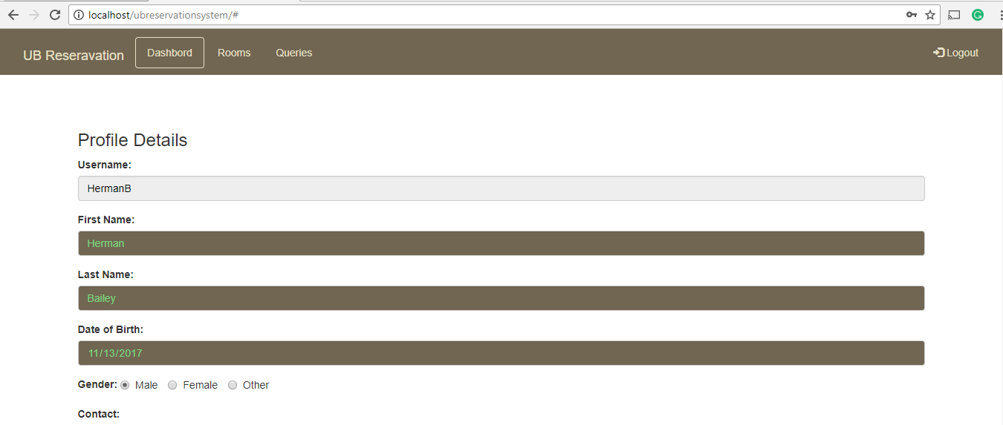
Admin will have a queries tab, to view student user’s queries and send response to the queries.

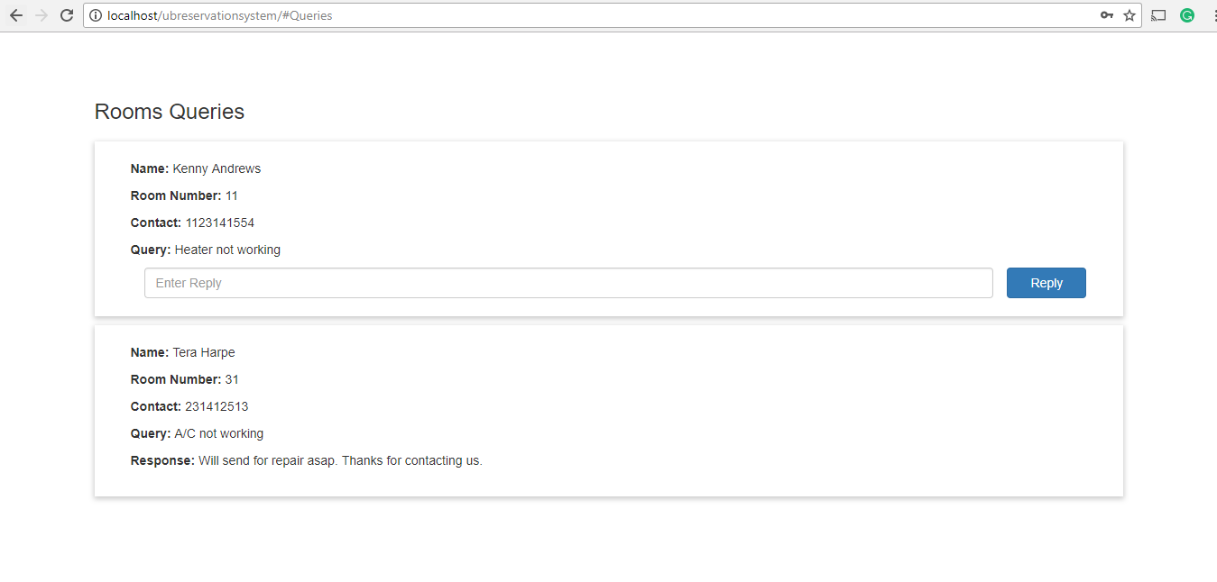
Queries/Issues got updated in the database:

Admin will have an option to Add Room:
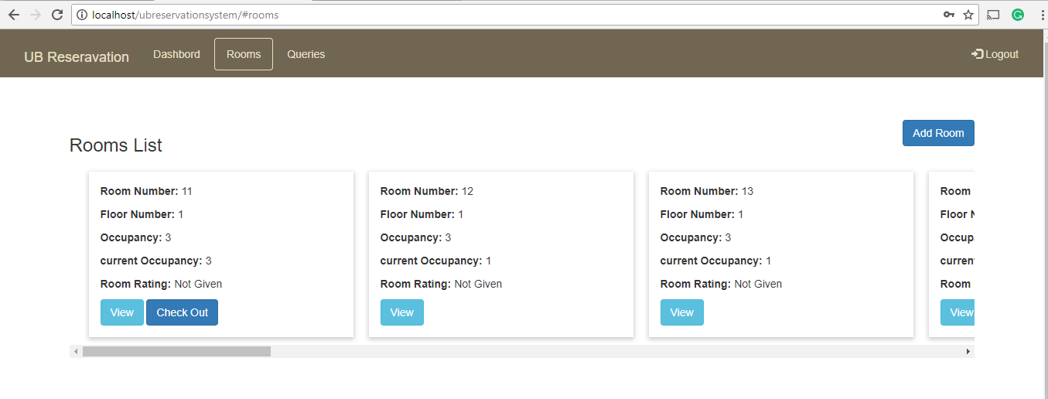
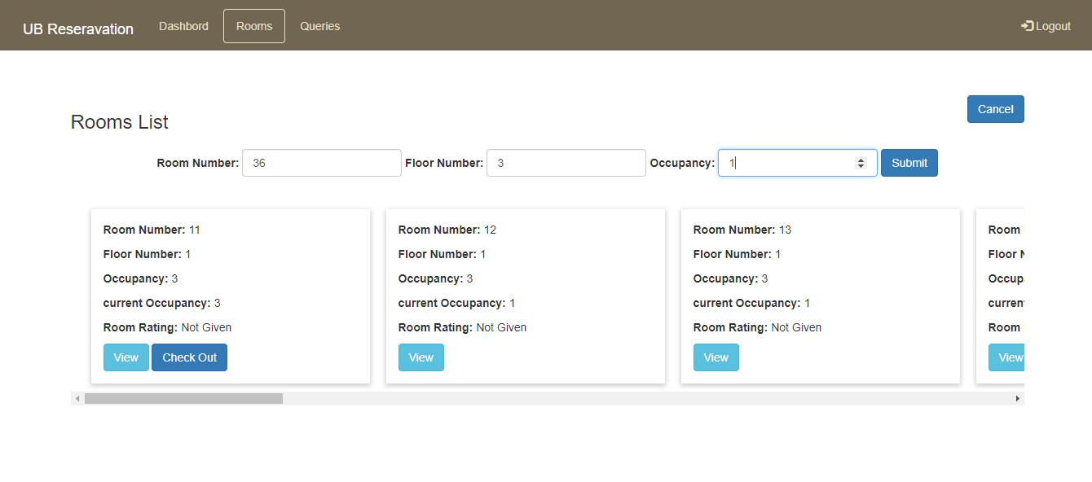
Room added into the table:
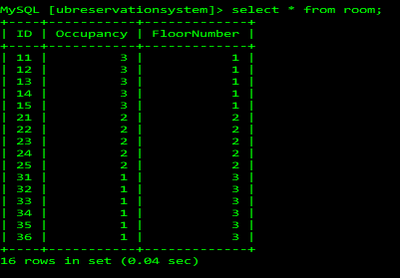
Admin can add rooms by updating Room Number, Floor Number and Occupancy.
Room rating at the time of checkout:
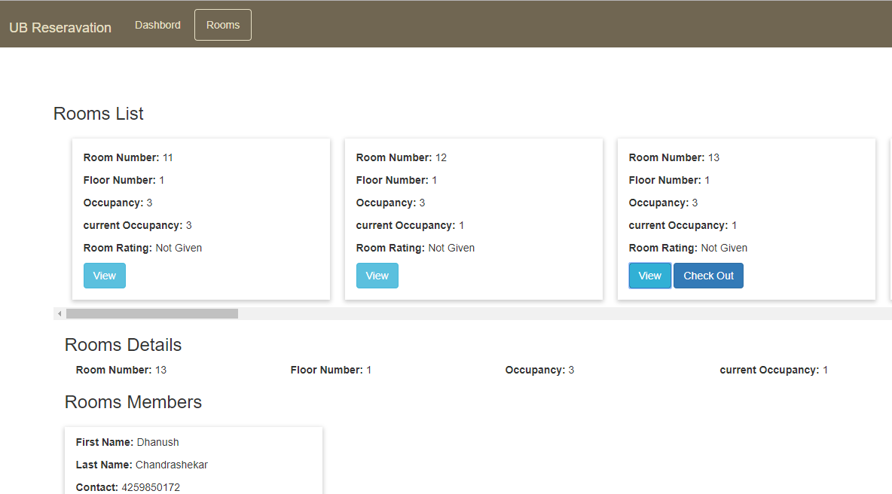
View Button is to check the details about the occupants in the room.
Check out is to vacate the room

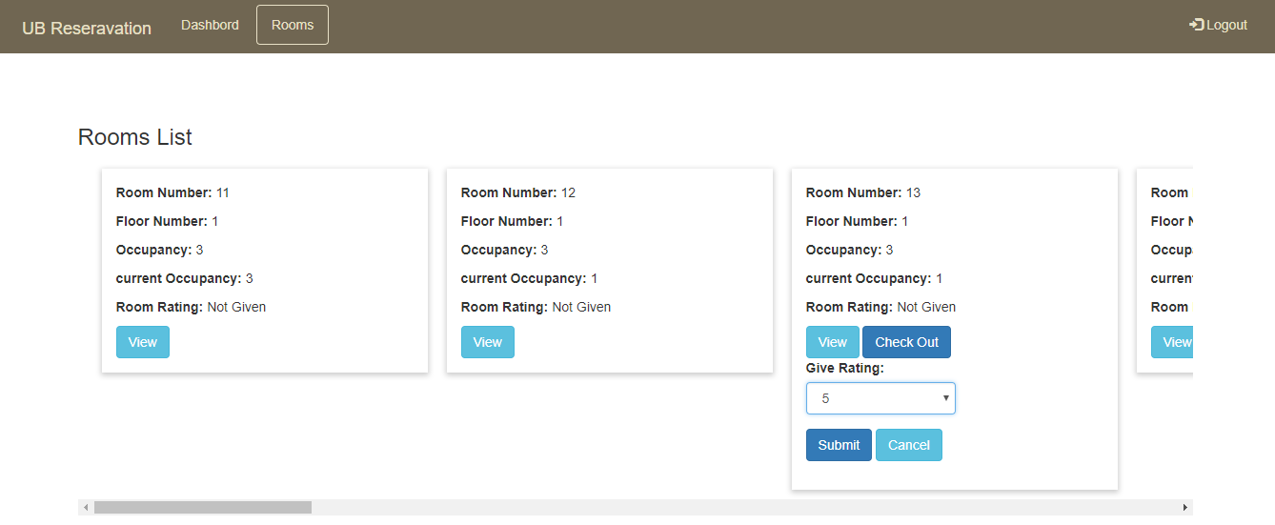
Once clicked on check out, it will ask the user to give rating (1 being least and 5 being best) for the room they stayed in.
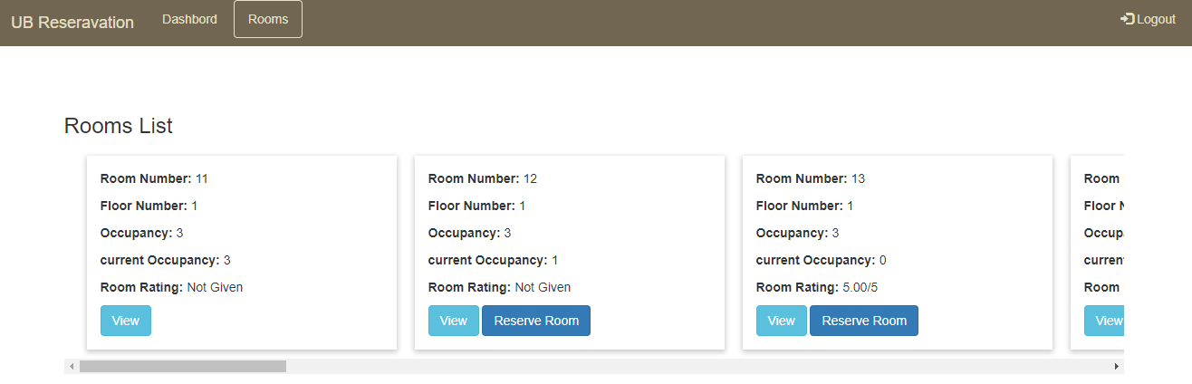
Logout from the application:

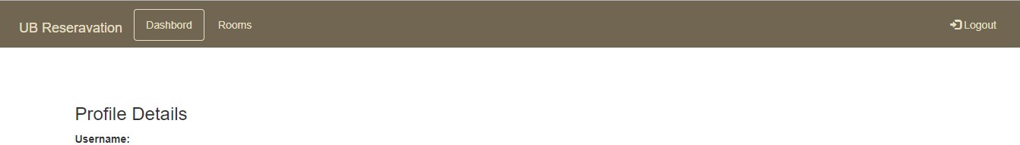
Click on this to Logout the application.

Conclusion:
This project has been an challenging task in terms of understanding and learning on how to create a database, tables, inserting data into tables and connecting the table. Fifth phase of the project is to develop a GUI, a web application with users to register and reserve rooms. I have learnt on the usage of PHP language to build the code with apache server, HTML web pages and ajex for connectivity. The implementation of this phase, has a GUI starting with login page and registration tab. Some of the data has already been inserted into the tables as a part of phase 4. The backend for the the application is a simple standalone API and frontend bootstrap which supports HTML, CSS and JS codes. In future with respect to this project I would want to develop this web application with more menu options and focus more on the design of the web application.

